Extraordinary Character Log App

This app is designed to store a player’s character information and to generate random numbers used in the XO roleplaying game. Players can log into the app and load their character or characters. The app has functions for calculating the characters success chance based on modifiers like, wound penalties, activating protonium, and skill modifiers.

Dependencies will include Giffy API, Firebase data base, and web hosting site not yet determined.

Tasks list:

* Setup: Create-react-app xo-character-log
* Call: Firebase data base if character is stored
* Render React State

Wireframe: Cell Phone view

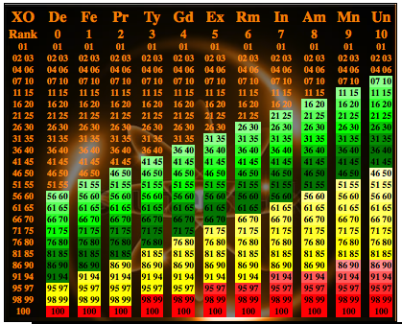

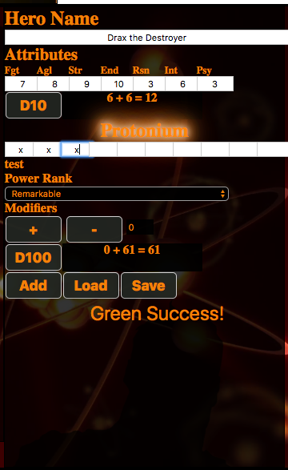

The app will be able to store a characters Name, Attributes, Protonium, Health Damage and character notes. If time permits, I want to also make a section for power stunts and what level of mastery. Power Stunts not mastered require an expenditure of Protonium. If a character has used up their protonium then power stunt cannot be performed unless mastered.

Week 1: Setup application components and functionality and ensure all critical parts such as the D10 and D100 generators function with all modifiers.

Week 2: Setup connection to Firebase database with native Firebase authentication so individual users can store their characters. Ensure props are properly stored and rendered in the app.

Final week: Setup the CSS and Design of the app.

Like to have: If there is time, I want to add Health and Protonium Modifiers, Notes and Power Stunts. I also want to add the success chart display when a roll of 100 is made to pop up and fade after a few seconds from the roll. I also want to add color themes and gender related background images.